PreBusiness Admit Decision Processing using imported Review Scores

Overview:
Complete instructions for this process are located here: https://wiki.bus.wisc.edu/display/KB/BBA+Admissions+Review+Group
Many of the steps described in the process are no longer needed as in 2019 a new on-line review process was created using an online admissions review form which negated the need for creation of large pdfs of resumes and essays.
However, the “Review Score Import” process is used to enable a means to identify all of the applications that will change to “Admit” status
Creating the review import file:
- Follow all of the steps under “Creating an Admissions Review Group”
  - None of the pdfs created will be used, but the program does associate the “Review Group Number” that is generated to all of the applications currently under review. This is needed when the “admit indicator score” is uploaded.
- Follow the steps under “Uploading Review Scores”
  - Using ONLY the application ids for those who will be ADMITTED, assign a score of 15 to each essay1 element and resume element as shown in the excel file below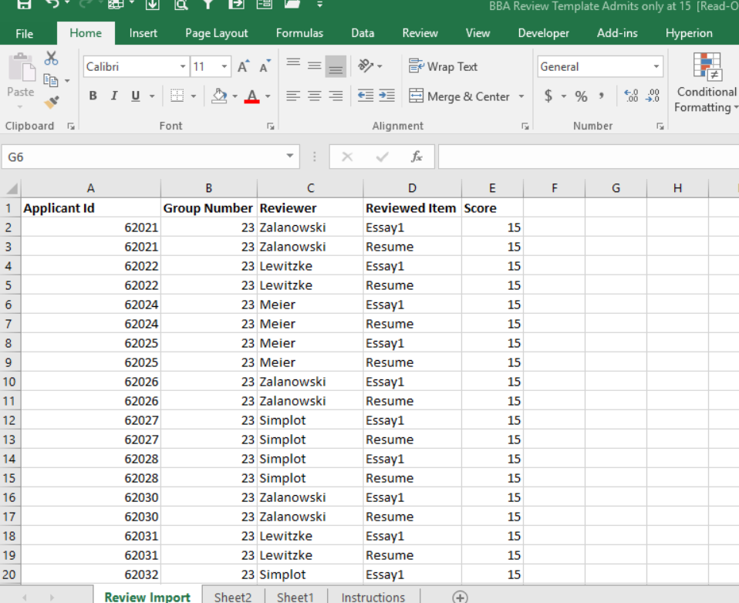

- Continue to follow the instructions to upload the file. Scores will be imported to the applications at 5:00 am the following morning.
- The query below will show all applications and the associated score
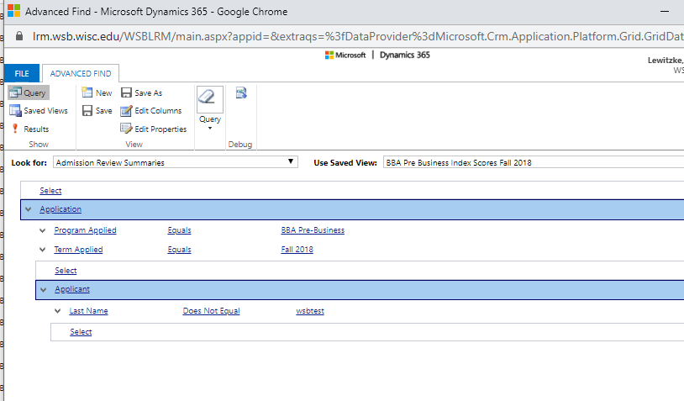
- Using the results of this query, sort the 1st column descending so the score of 15 is at the top of the list.
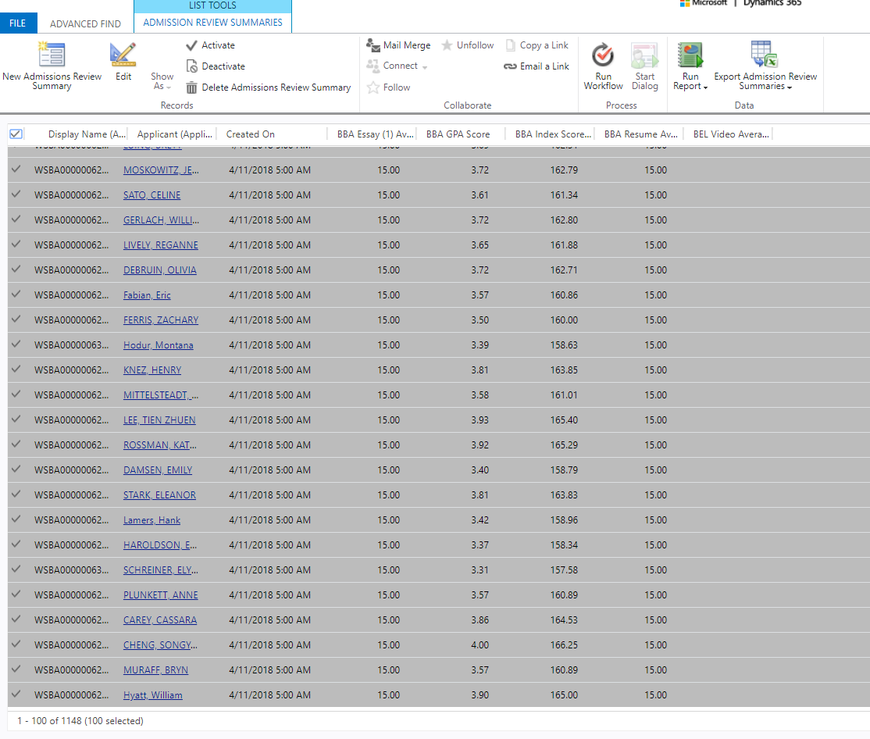
- Select the checkmark at the top of the page to select all the applications on the page.
- Run the workflow “App Bulk set status to Admitted (from Review Summary Entity)
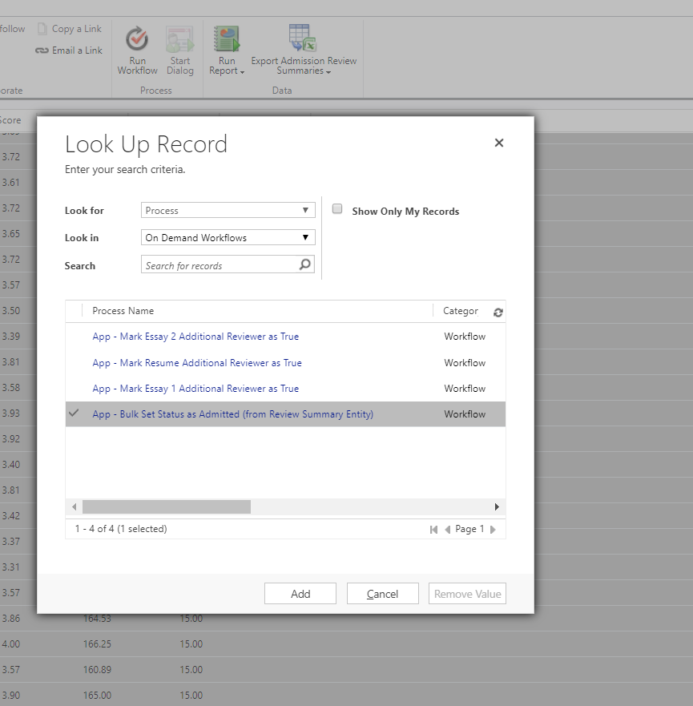
- Continue this process for subsequent pages until all the Review Score 15 (Admit indicator) have been admitted.
- Go back to the Application Advanced find for PreBusiness. Find the applications that are to be Waitlisted and manually change them to waitlist using the standard process.
- All other applications (now in Review) can be bulk set to Deny.

